Experiment 34
Create a Circle using OpenCV
Aim: To create a white image of user-defined size and draw a circle using OpenCV.
Procedure:
- Import OpenCV and NumPy libraries.
- Get the image height and width.
- Create a white image.
- Draw a circle using cv2.circle().
- Save the output image.
Program:

import cv2
import numpy as np

h = int(input("Enter height: "))
w = int(input("Enter width: "))

img = np.ones((h, w, 3), dtype=np.uint8) * 255

center = (w//2, h//2)
radius = min(h, w)//4

cv2.circle(img, center, radius, (255, 0, 0), 3)

result = cv2.imwrite(r"D:\Amrita\Documents\circle.png", img)

print("Image saved:", result)
Input:
500, 700
Output:
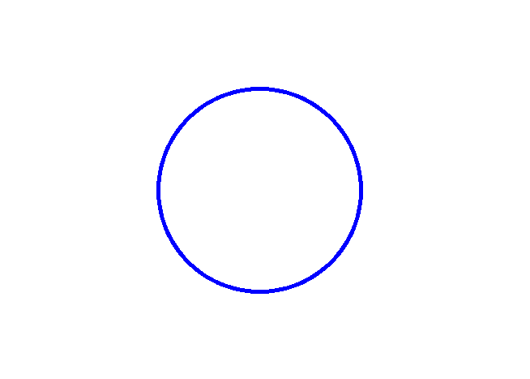
Result: A white image with a blue circle is created and saved successfully.

